Q1. Three coins are tossed simultaneously. Let X denote the number of times the coin comes up with heads. Compute the PMF and the CDF values for all possible values of X.

Ans.

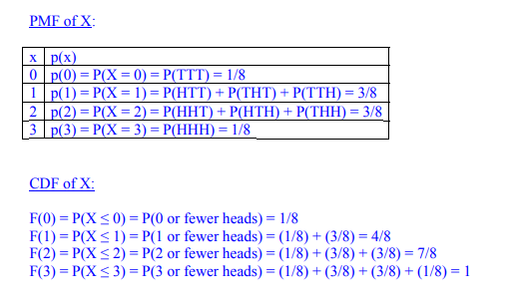

**Test Cases:**

**Test Case-1:**

X=0

PMF=0.125

**Test Case-2:**

X=2

PMF=0.375

**Test Case-3:**

X=3

PMF=0.125

Q2. Three coins are tossed simultaneously. Let X denote the number of times the coin comes up with heads. Compute the CDF values for all possible values of X.



**Test Cases:**

**Test Case-1:**

X=0

CDF=0.125

**Test Case-2:**

X=1

CDF=0.5

**Test Case-3:**

X=3

CDF=1

Q3. Calculate the PMF of the random variable X. Assume that X can take on the values given in the file (numbers.txt).

**Test Cases:**

**Test Case-1:**

X=1

PMF=0.2985

**Test Case-2:**

X=5

PMF=0.0793

**Test Case-3:**

X=8

PMF=0.0517

Q4. Calculate the CDF of the random variable X. Assume that X can take on the values given in the file (numbers.txt).

**Test Cases:**

**Test Case-1:**

X = 3

CDF = 0.6023

**Test Case-2:**

X=5

CDF=0.776

**Test Case-3:**

X=4

CDF=0.6967

**Practice Question**

Q1. Recall the statistical word printing question from last time. This question uses the same dataset, which is given below. This time however you will print sentences randomly following the specified distribution. For example, consider that you gave the input as the word “I”. Lets say that the words that follow “I” along with their frequencies are, for instance, {love: 9, am:1, hate:5, will: 2}. Now suppose you have to print 34 random sentences of length 2 starting with I. The system should print “I love” 18 times, “I am” 2 times, “I hate” 10 times, “I will” 4 times approximately.

Dataset:

I love the world and the things in it.

I love the way cheetah runs.

I am a man of honor.

I will be a rich guy.

I am a teenager so I am a rebel.

I am an iconoclast and a fighter

I believe in education.

I love everything.

I watch a movie every day.

I hate pollution.

I love the work of god.

I love the beauty of this world.

I adore the way people try solve hard things.

I am nothing but a blade of grass.

I will unleash a lot of prophecies and will bring down hordes of legions unto this earth to destroy you.

I love doing things in a peculiar way.

I love and hate probability. It is so stupid and fun at the same time.

I love the way software programs work.

I love my room.